Even Semester (2019)



**BINUS UNIVERSITY**



**BINUS INTERNATIONAL**



**Assignment Cover Letter**

**(Individual Work)**

|  |  |  |  |  |  |  |  |
| --- | --- | --- | --- | --- | --- | --- | --- |
|  |  | | |  |  |  |  |
| **Student Information**: | **Surname** | | |  |  | **Given Names**  Livander | **Student ID Number**  **2201796384** |
| 1. | Surya | |
|  |  |  |  |  |  |  |  |
| **Course Code** | **: COMP6510** |  |  |  |  | **Course Name** | **: Programming Language** |
| **Class** | **: L2AC** |  |  |  |  | **Name of Lecturer(s)** | **: Jude Martinez** |
|  |  |  |  |  |  |  |  |
| **Major** | **: CS** |  |  |  |  |  |  |
| **Title of Assignment**  (if any) | : Leagrove’s ChatRoom |  |  |  |  |  |  |
| **Type of Assignment**    **Submission Pattern** | **: Final Project** | |  |  |  |  |  |
| **Due Date** | **: 01 - 07 - 2019** | |  |  |  | **Submission Date** | **: 01 – 07 -2019** |

The assignment should meet the below requirements.

1. Assignment (hard copy) is required to be submitted on clean paper, and (soft copy) as per lecturer’s instructions.
2. Soft copy assignment also requires the signed (hardcopy) submission of this form, which automatically validates the softcopy submission.
3. The above information is complete and legible.
4. Compiled pages are firmly stapled.
5. Assignment has been copied (soft copy and hard copy) for each student ahead of the submission.

# Plagiarism/Cheating

BiNus International seriously regards all forms of plagiarism, cheating and collusion as academic offenses which may result in severe penalties, including loss/drop of marks, course/class discontinuity and other possible penalties executed by the university. Please refer to the related course syllabus for further information.

# Declaration of Originality

By signing this assignment, I understand, accept and consent to BiNus International terms and policy on plagiarism. Herewith I declare that the work contained in this assignment is my own work and has not been submitted for the use of assessment in another course or class, except where this has been notified and accepted in advance.

Signature of Student:

Livander Surya

**Table of Contents**

* Project Specification
* Solution Design
* What was implemented
* How it works
* Evidence

**Project Specification**

Why I made this Chat Program? This Chat Program is for studying purpose, and we all know that students have their own activities beside studying, and because of that many student don’t have time for gathering with their friends to studying, discussing, sharing knowledge about the subject matery. But when some students invite their friends to study together, usually there is at least one guy who can’t attend the gathering. It’s really unfortunate for those guys if they can’t study properly by their own, especially when they need someone who can explain to them about the subject, or maybe if they needs someone to discuss about the subject. Therefore, having a chat program can make them study properly, they can also do a voice chat for a better interaction

**Solution Design**

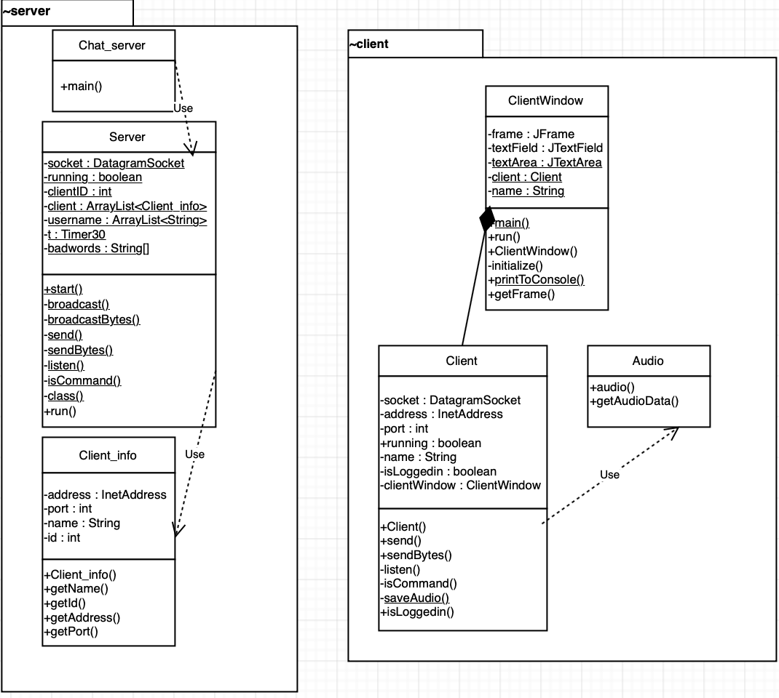

**What was implemented**

import java.net.DatagramPacket;  
import java.net.DatagramSocket;

import java.net.UnknownHostException;  
import java.net.InetAddress;  
import java.time.LocalDate;  
import java.time.LocalTime;  
import java.util.ArrayList;

import java.util.Base64;  
import java.io.File;  
import java.io.IOException;

import java.io.FileOutputStream;  
import java.nio.file.Files;

import java.awt.event.ActionEvent;  
import java.awt.event.ActionListener;

import java.awt.*;

import javax.swing.*;  
import javax.swing.JFrame;  
import javax.swing.JScrollPane;  
import javax.swing.JTextArea;  
import javax.swing.JButton;  
import javax.swing.JPanel;  
import javax.swing.JTextField;  
import javax.swing.UIManager;  
import javax.swing.text.DefaultCaret;

import javax.swing.*;  
import javax.sound.sampled.*;

* **java.net** : The Socket class for connecting to particular ports on specific Internet hosts and reading and writing data using streams.
* **java.time** : The main API for dates, times, instants, and durations.
* **java.util** : for importing a class or a method or any data from another package where it is predefined
* **java.io** : API that comes with Java which is targeted at reading and writing data (input and output)
* **java.nio :** like java.io but this one is buffer oriented, while io is stream oriented. Data is read into a buffer from which it is later processed. You can move forth and back in the buffer as you need to. This gives you a bit more flexibility during processing.
* **java.awt** : API to develop GUI or window-based applications in java
* **javax.swing** : is a set of program components for Java that provide the ability to create graphical user interface ( GUI ) components Unlike AWT, Java Swing provides platform-independent and lightweight components. The javax.swing package provides classes for java swing API such as JButton, JTextField, JTextArea, etc.
* **java.sound** : API for effecting and controlling the input and output of sound media

**How it works**

So, basically the Server relays what the users request in Client class, for example client send a message, than the message will be delivered to the server, then the server will deliver it again to the other client. First we run the server, and then it will print out server start on port 1218, and then we run the ClientWindow for the interface where the user will chat. The program can run many ClientWindows to chat each other because this program is multi-threaded program. After the user runs ClientWindow, they have to input their username and enter the chat room. Inside the chat room the user can talk to each other while there is BOT that broadcasting every 60 seconds about commands in the chatroom that the user can use, there are \help (to get all the commands in chat) and \time (to get the date and time at that moment). Users can’t swearing in this chatroom because this chatroom is for studying purpose. The rude words will automatically change into **** if the server detects rude words in the user’s chat. Finally there is a voice chat that will automatically sent to the other client, there is a record button to record the sound, then the other user can hear it in .wav file, the name of the file will be automatically has it’s own date and time, so the user knows when did that sound sent. First the program will record the sound, and change it into string, then send it to other client, then change it back to bytes and save the file in .wav file.

**Evidence**

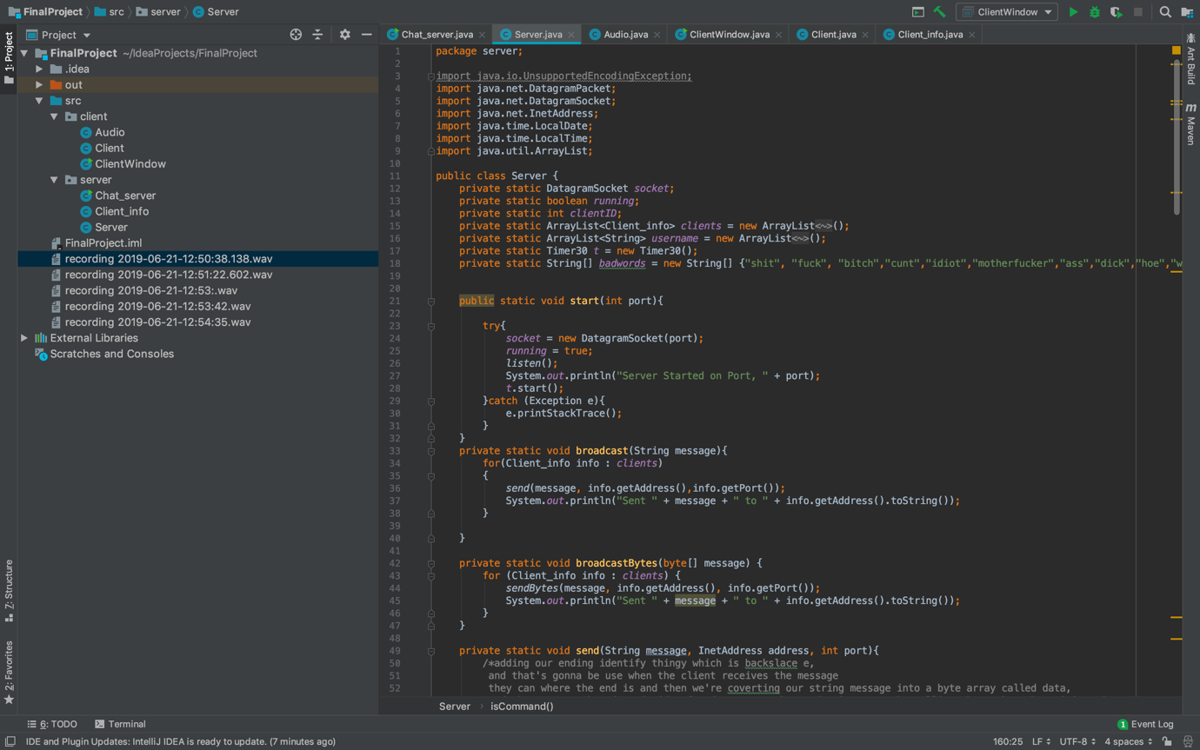

This is how my code look like, there are 6 classes there, inside 2 packages client and server, server is for the server chat, and client is for the people who use the chat program. The main class is the Chat_server.java, Server.java class for everything you want to do in this chat program, start the program, sending message, broadcasting, stop the program, and ETC. Client_info.java is for the setter getter. Second packages is client package which has Audio.java for recording voice and sending the voice file in wav, Client.java is like Server.java but this is for the client, so basically the Server relays what the users request in Client class, for example client send a message, than the message will be delivered to the server, then the server will deliver it again to the other client. Finally the ClientWindow.java is the scene builder, for the user interface.

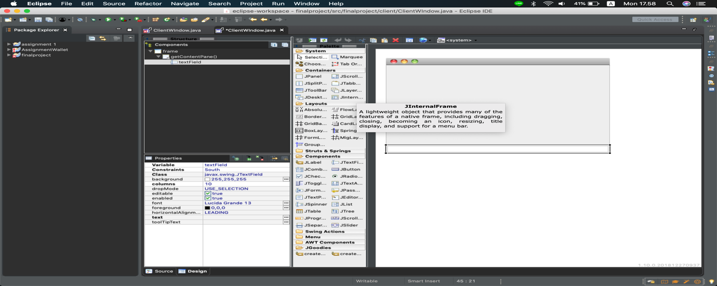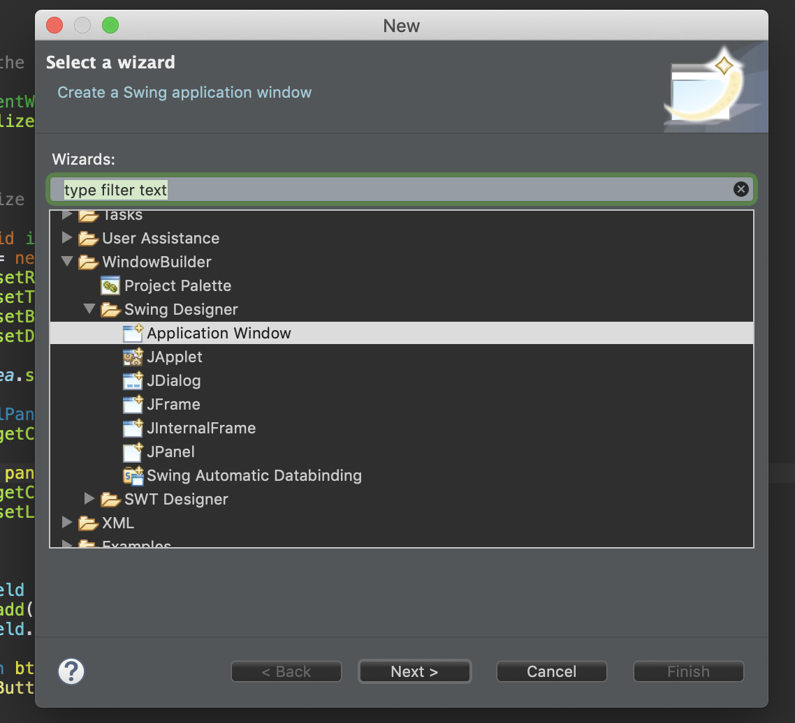

This is how I made the interface, I made it in eclipse because I’m using the Application window for making the scene builder, after I’ve done making the interface, I copy the code and paste it in the IntelliJ IDEA which is my compiler for this project

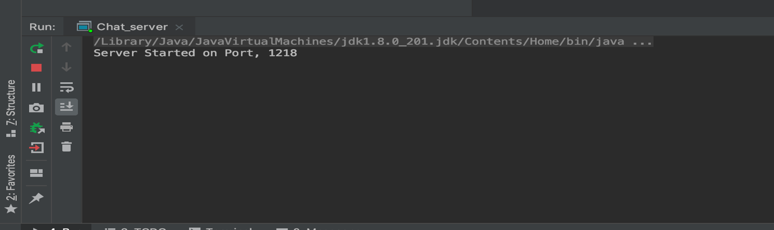

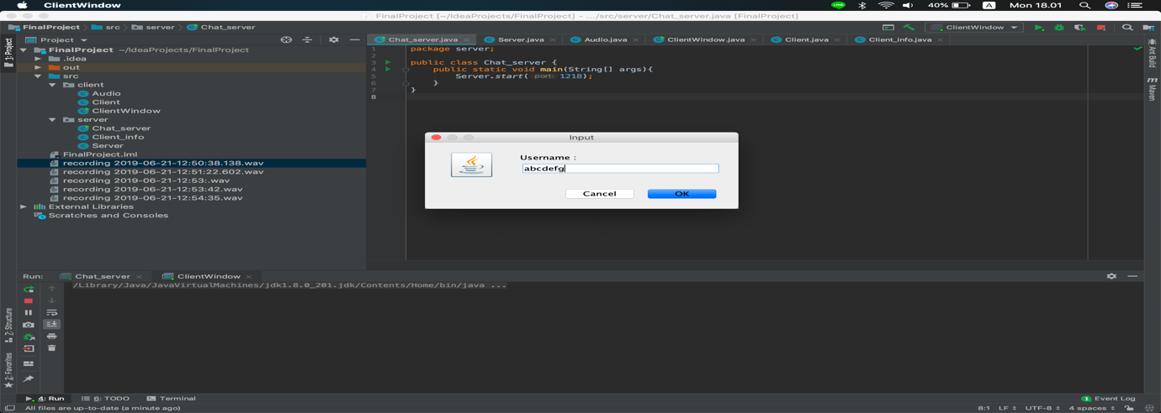

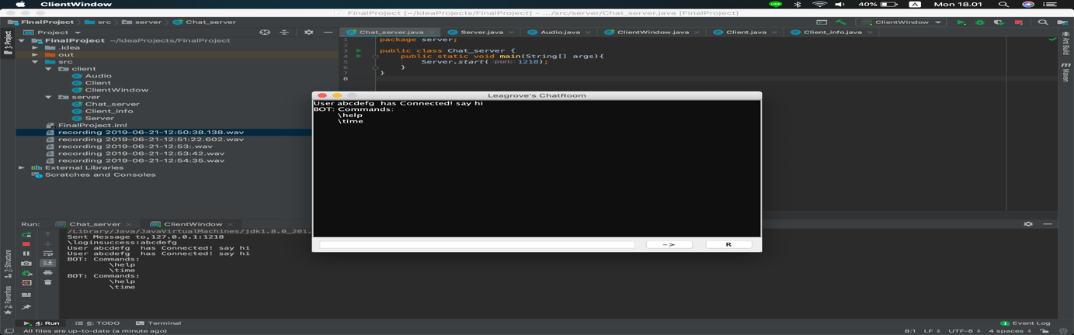

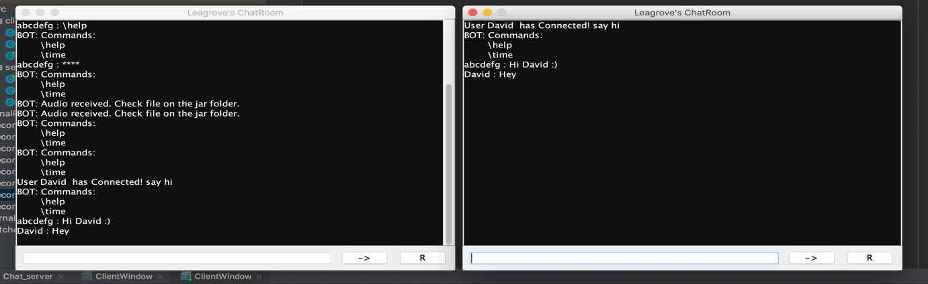

Finally, this how the chat program look like, first we run the server, after the server is on, people can run the ClientWindow to join the connect to the server. Input their username and press enter to connect. There is BOT who tells the user about commands in this chat every 1 minute. There are also -> button to send chat and R button which stands for Recorder to send a voice chat.

**Video link**

https://drive.google.com/file/d/1GMFUFOOoMTWAigQ2pVCQEk_1e9o3XtJK/view?usp=sharing